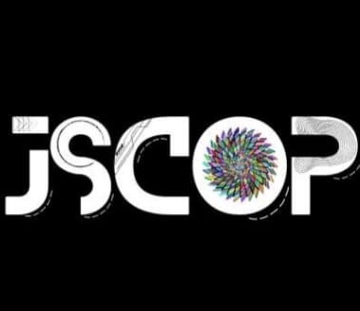**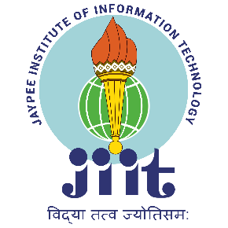JIIT STUDENT CONFERENCE ON OPTICS AND PHOTONICS**

**JSCOP 5.0**

**(15th-16th April 2022)**

**JIIT-OPTICA, Department of Physics & Materials & Engineering**

**JIIT Noida**

|  |  |  |  |  |
| --- | --- | --- | --- | --- |
| **DATE** | **TIME** | **EVENT** | **SPEAKER** | **VENUE** |
| DAY 1  15TH April 2023  (Saturday) | 9:30AM-10:30AM | Opening |  | Auditorium |
| 10:30AM-11:15AM | Talk 1 | Prof. CM Chandrashekar  (IISc Bangalore) | LT-4 |
| 11:15AM-11:35AM | Tea Break |  |  |
| 11:35AM-12:20PM | Talk 2 | Dr. Ritwick Das (IIT Delhi) | LT-4 |
| 12:20PM-02:00PM | Lunch |  |  |
| 02:00PM-04:00PM | Blind Coding |  | CL 1- CL 4 |
| 04:00PM-04:20PM | Tea Break 2 |  |  |
|  | 04:20PM-05:30PM | CCC (Create-Check-Crack It) |  | Communication Systems Lab EL11 |
|  |  |  |  |  |
| DAY 2  16TH April 2023  (Sunday) | 10:00AM-10:45AM | Talk 3 | Dr. Gagan Kumar (IIT Guwahati) | LT-4 |
| 10:45AM-11:05AM | Tea Break |  |  |
| 12:00PM-01:30PM | Lunch |  |  |
| 01:30PM-03:30PM | Ideathon |  | Audi/LT-4 |
| 03:00PM-04:30PM | Squid Game |  | JBS |
| 04:30PM-06:00PM | Closing Ceremony |  | Auditorium |
| 06:00PM-06:30PM | Tea Break |  |  |